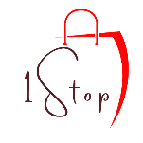
JULY, 2026
ONESTOP THERAPEUTICS
EQUIPMENT CATALOGUE
CARTEGORY 1: COGNITIVE & FINE MOTOR
ITEM | QUANTITY | PRICE
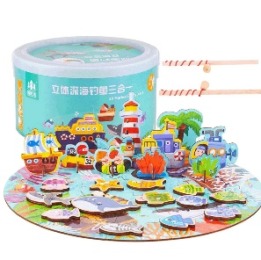  Fishing jigsaw puzzle  (3 in 1 – Large Box) | 1 box | 35,000/=
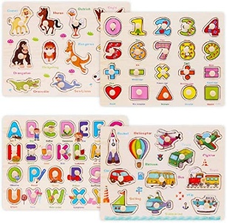  Fine motor wooden puzzles | 1 | 15,000/=
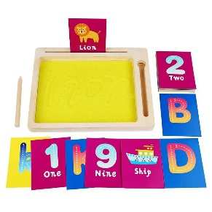  Word pad  (With writing Sand) | 1 Box | 30,000/=
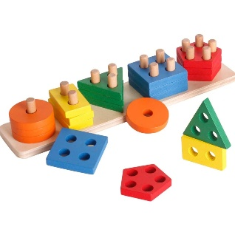  Geometric Shapes | 1 box | 30,000/=
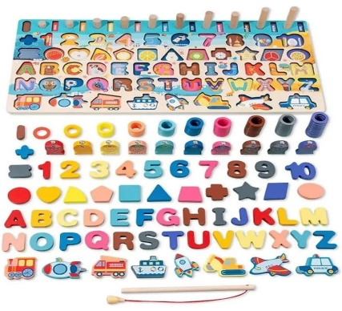  Logarithmic board  (5 Games in 1) | 1 | 45,000/=
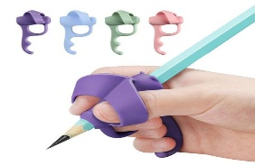  Pencil grip | 1 | 12,000/=
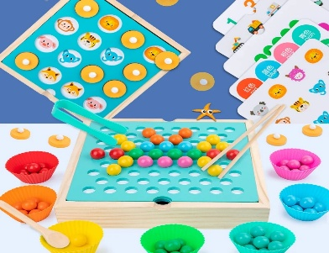  Memory game  (4 Games in 1) | 1 | 45,000/=
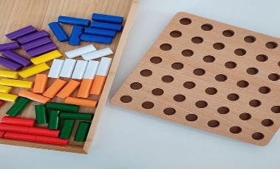  Colorful peg-board | 1 | 35,000/=
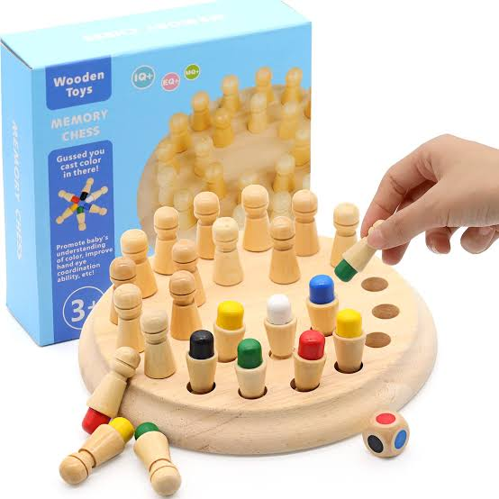  Memory chess | 1 | 30,000/=
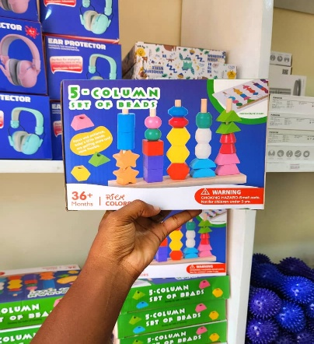  Wooden Beads set | 1 | 45,000/=
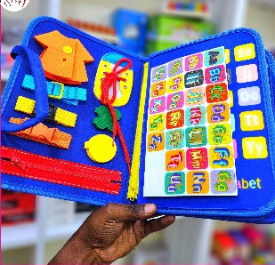  Busy Book  (8 pages | 30 Games) | 1 | 45,000/=
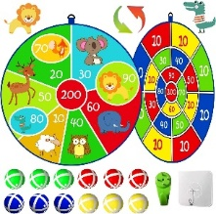  Plastic ball darts | 1set | 15,000/=
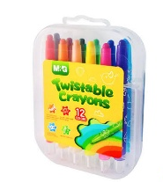  Twistable Crayons | 12 colors | 8,000/=
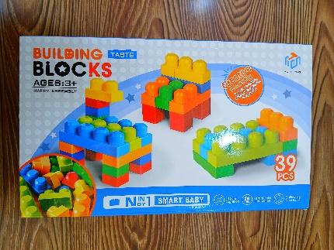  Lego blocks | 1 package | 35,000/=

CARTEGORY 2: SENSORY EQUIPMENT
ITEM | QUANTITY | TOTAL PRICE
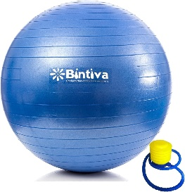  Gym ball + pump | 55cm | 45,000/=
 | 65cm | 55,000/=
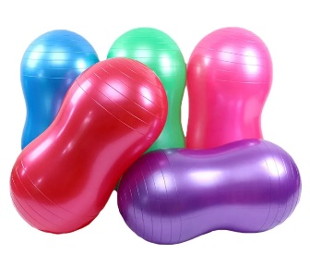  Peanut Gymball + Pump | Small | 45,000/=
 | Medium | 55,000/=
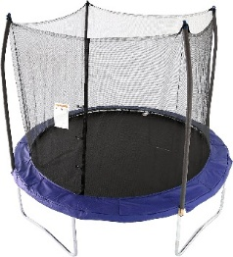  Trampoline | 4.5ft | 300,000/=
 | 6ft | 700,000/=
 | 8ft | 900,000/=
 | 10ft | 1,000,000/=
 | 12ft | 1,300,000/=
 | 14ft | 1,600,000/=
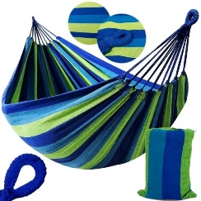  Hammock  (Children - Medium) | 1 | 60,000/=
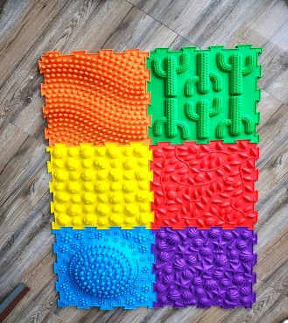  Sensory mats | 1 set  (6 mats) | 130,000/=
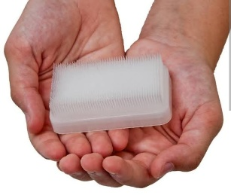  Sensory Brush | 1 | 15,000/=
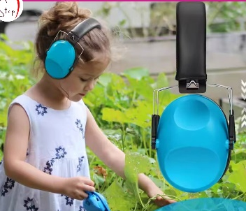  Noise Cancelling ear Muffs | 1 | 45,000/=
Bubble fish light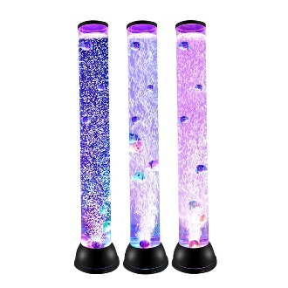 | 85cm height | 150,000/=
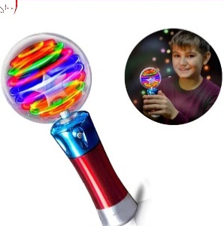  Visual Stimulation Lights | 1 | 30,000/=
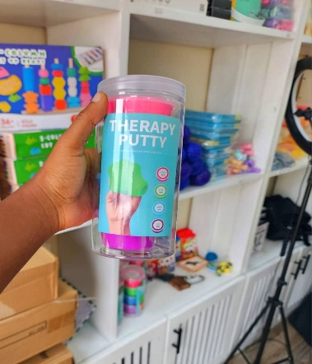  Therapy putty | 1 set  (4 pc) | 60,000/=
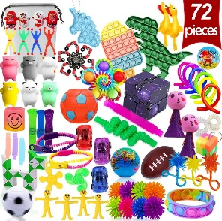  Fidget set | 1 Box | 60,000/=
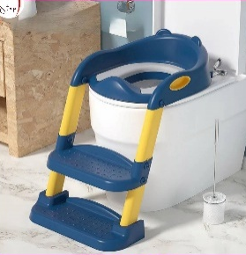  Potty Trainer | 1 | 70,000/=
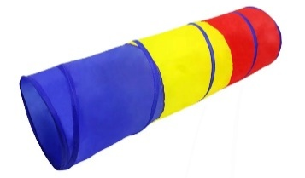  Sensory Tunnel | 180cm x 46cm | 90,000/=
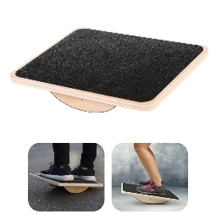  Wooden balance board | 1 | 70,000/=
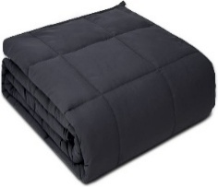  Weighed blanket | 4.5kg | 175,000/=
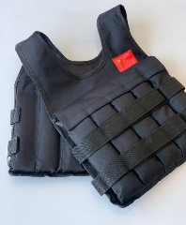  Weighed vest  (Adjustable weights) | 5kg | 95,000/=
 | 8kg | 100,000/=
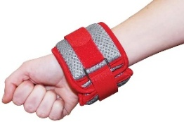  Weighed bracelets | 1 pair  (2 = 0.25 kg each) | 30,000/=
 | 1 pair  (2 = 0.5 kg each) | 40,000/=
 | 1 pair  (2 = 1 kg each) | 50,000/=
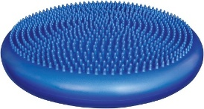  Spiked Balance cushion | 1 | 55,000/=
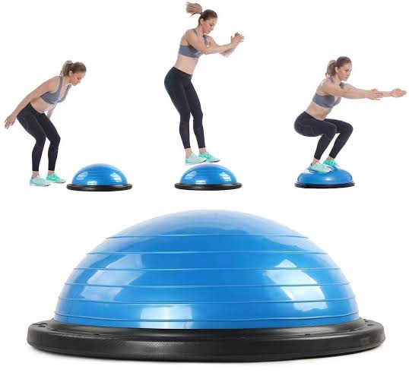  Balance Ball | Small | 110,000/=
 | Large | 210,000/=
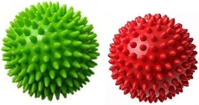  Spiked massage ball | 1 | 25,000/=
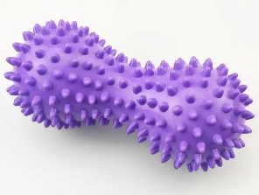  Spiked massage ball  (Peanut shaped) | 1 | 25,000/=
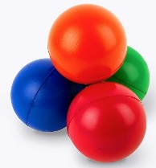  Antistress balls | 1 | 15,000/=
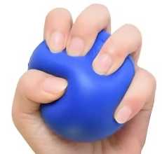  Spongy exercise balls | 1 | 15,000/=
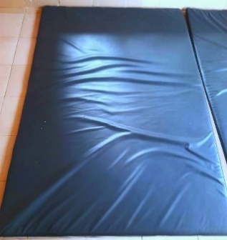  Therapy mat | (6ft x 4ft) | 90,000/=
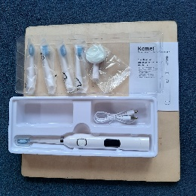  Electric toothbrush | 1 | 35,000/=
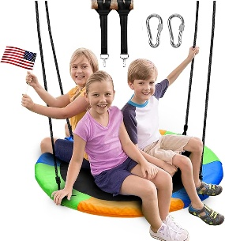  Indoor Swing | 1 | 250,000/=
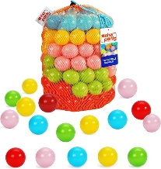  Plastic Colored balls | 50 pcs | 40,000/=
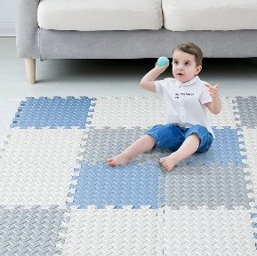  Interlocking mats | 1.8M x 1.5M | 140,000/=
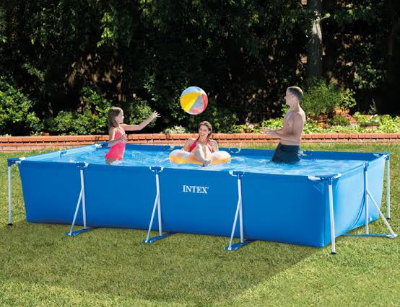  Intex Swimming pool | 4M x 2M x 1M | 1,100,000/=
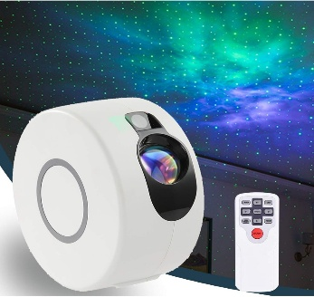  Starry Night Light projectorStarr | 1 | 210,000/=
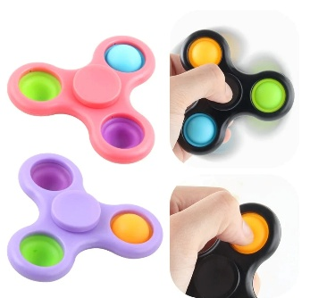  Fidget Spinners | 1 Piece | 10,000/=

SPEECH THERAPY EQUIPMENTS
ITEM | QUANTITY | PRICE
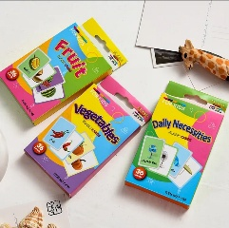  Flashcards | 1 box | 15,000/=
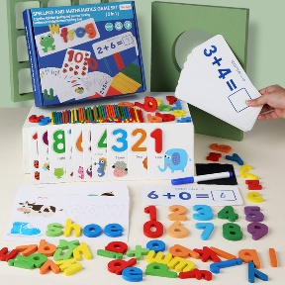  Spelling game | 1 box  (4Games in 1) | 45,000/=
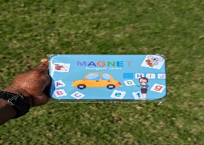  Magnetic recognize word | 1 pc | 25,000/=

CATEGORY 3: MOTOR FUNCTION
ITEM | QUANTITY | PRICE
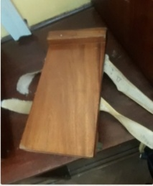  Arm Trolley | 1 | 45,000/=
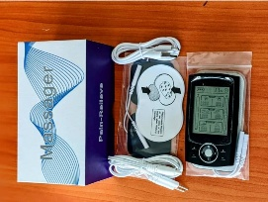  TENS | 2 Channels | 200,000/=
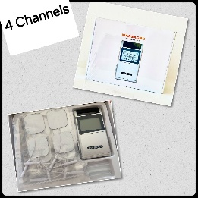  TENS | 4 Channels | 250,000/=
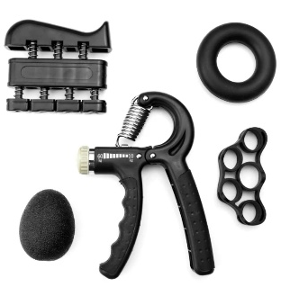  Hand grip Set  (Adjustable Resistance) | 1 Sets | 60,000/=
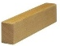  Wooden blocks | 10 | 20,000/=
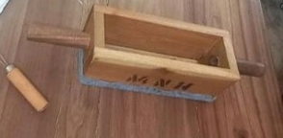  Push and Pull | 1 | 40,000/=
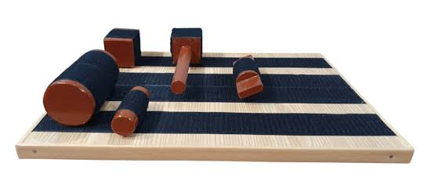  Rehabilitation Velcro board | 1 | 60,000/=
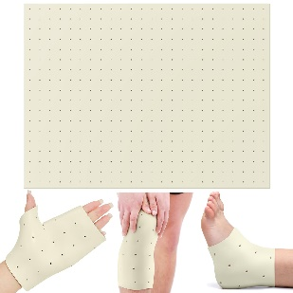  Thermoplast  (Perforated) | (61cm x 46cm) | 140,000/=
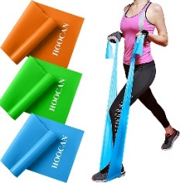  Elastic resistance band | 1 meter | 18,000/=
 | 2 meter | 33,000/=
 | 3 meter | 48,000/=
 | 4 meter | 63,000/=
 | 5 meter | 78,000/=
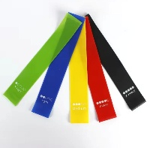  Resistance band loop set  (Different resistance) | 5 pcs | 50,000/=
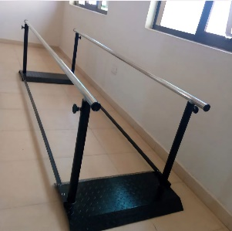  Parallel bar  (Stainless steel) | 3 Meters | 1,100,000/=
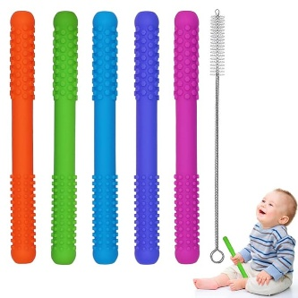  Chewing tube | 1 piece | 15,000/=
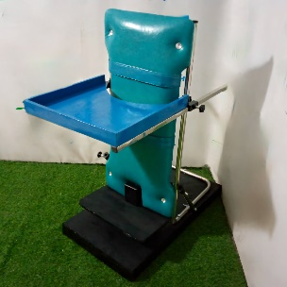  Paediatric standing frame  (Supine Stand) | 1 | 350,000/=
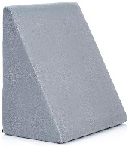  Prone wedge | 1 | 160,000/=
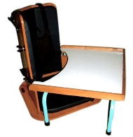  Corner chair | 1 | 250,000/=
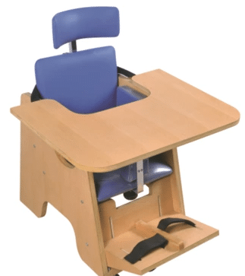  Special chair | 1 | 300,000/=
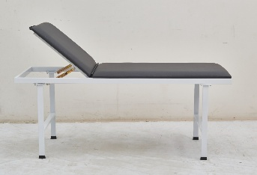  Treatment table | 6ft x 2ft | 950,000/=
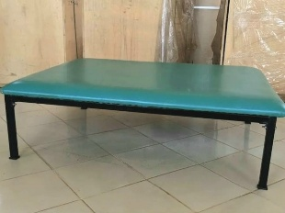  Treatment table | 6ft x 5ft | 1,550,000/=
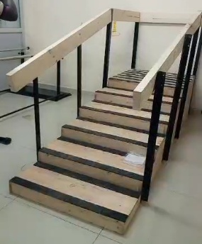  Training Stairs | 1 | 900,000/=
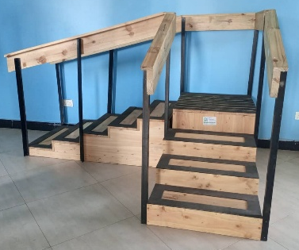  Angled Training Stairs | 1 | 1,300,000/=

DESIGNS & SETUPS:
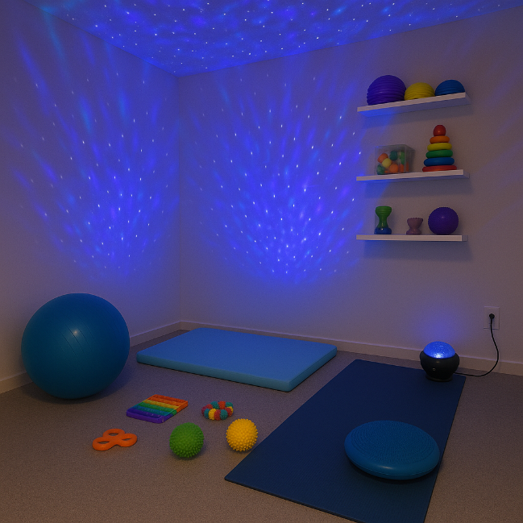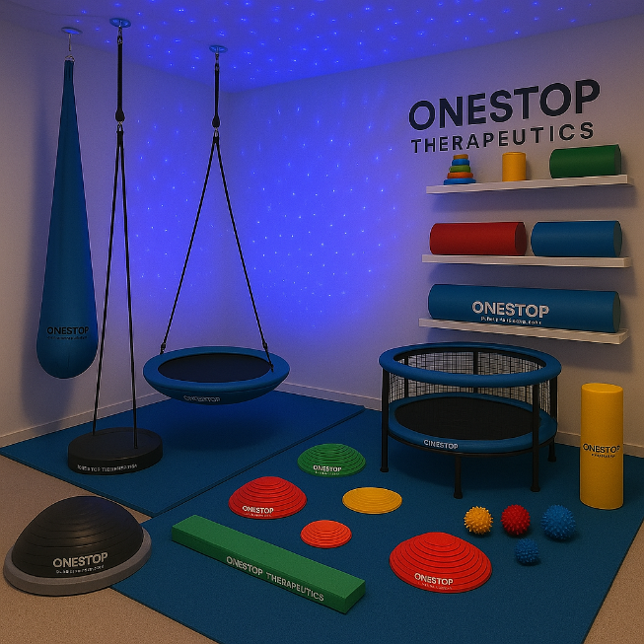
We design Sensory Rooms tailored to your needs, from simple setups to more sophisticated environments depending on your preference and budget.
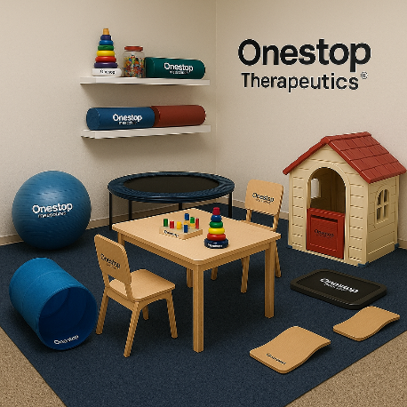

We also design functional and calming therapy rooms that support effective treatment and a welcoming experience. Each space is customized based on your professional needs, client base and available space
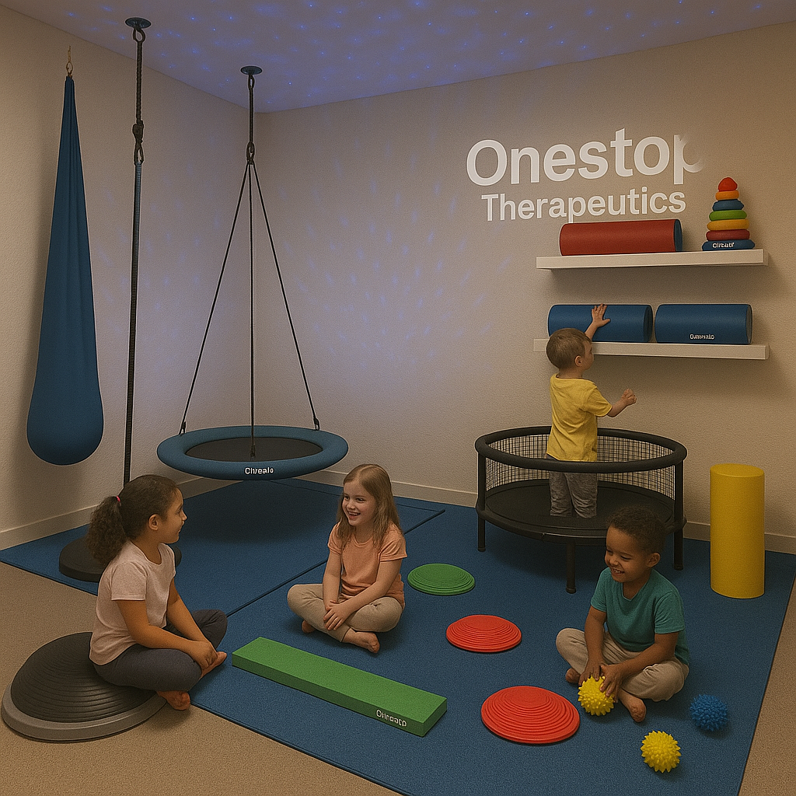

Order through: 0 794 700 946 Instagram: onestoptherapeutics
Delivery services Available all over Tanzania
Karibu Sana.

